HACKUP TECHNOLOGY PVT.LTD

INTERNSHIP : AI – POWERED SOC & DIGITAL FORENSICS
WEEK – 1 : PROJECT REPORT

BY :
P. AKSHAYA (24202)
B.SC.CS (SSS)

SOC ALERT SIMULATION

PROJECT TITLE :
(analyze a scenario involving multiple failed login attempts and identify the issue , affected system , and response strategy)

SOC ALERT SIMULATION:
soc alert simulation is a fake or test security problems are created, such as failed login attempts or suspicious access, so,the security analysts can learn how to detect, investigate, and respond to cyber threats in a real-world environment.

COMMON TYPES OF SOC ALERT SIMULATIONS :
- Brute-force attacks
- Phishing detection
- Malware alerts
- Unauthorized access attempts
- Suspicious network traffic
- Data exfiltration alerts

INTRODUCTION:
SOC analysts investigate suspicious activities and work to prevent unauthorized access to systems and data. security alert related to multiple failed SSH login attempts was analyzed using Linux log files in Kali Linux. The investigation helped to understand the login attempts were suspicious and identify any security risks.
this investigation was identify suspicious login activity, and systems or accounts were targeted, study the attack pattern, and suggest suitable response and prevention methods.

REQUIREMENTS :
- Kali Linux

- Linux Terminal

- SSH Logs

- grep Command

- cat Command

COMMANDS USED :
1. create a new log file
Command - cat > p_akshaya.log
It is used to create a new log file named soc_alert.log and manually enter log data into it.
How it works
- cat → reads input from the keyboard.
- > → redirects the input into a file.
- p_akshaya.log → name of the file being created.

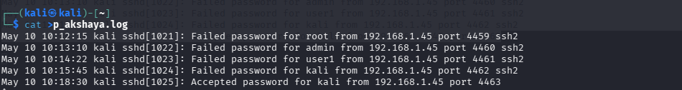

2. Viewing the Log File
Command - cat p_akshaya.log
This command is used to open and view the full log file. It allows the investigator to check all system activities and understand what events were recorded during the incident
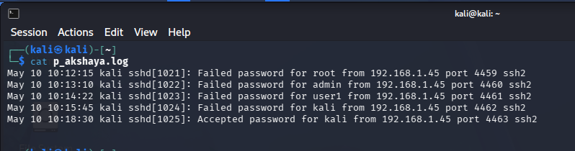

3. Identifying Failed Login Attempts
Command - grep "Failed password" soc_alert.log
Purpose:
This command searches the log file for failed SSH login attempts. It helps identify suspicious login activity, such as repeated incorrect password attempts that may indicate a brute-force attack or unauthorized access attempt.

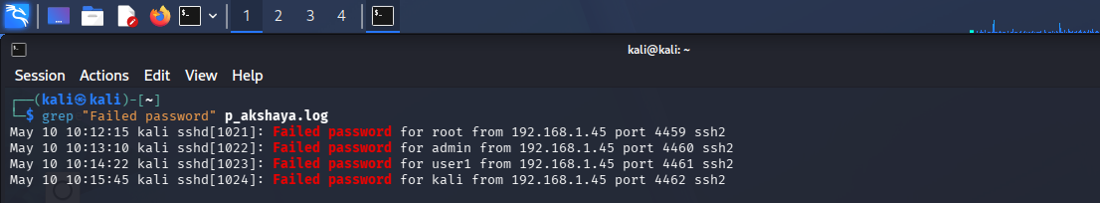

4. Identifying Successful Logins
Command - grep "Accepted password"p_akshaya.log

This command is used to find successful SSH login attempts in log file. It shows the a user entered the correct password and successfully logged into the system.
By checking these successful login records, the analyst can understand who accessthe system, when the login happened, and from which IP address the connection was made. This helps to verifying the login activity was normal or suspicious.

5. Counting Failed Login Attempts
Command - grep "Failed password" _pakshaya.log | wc -l
This command counts how many failed SSH login attempts are present in the log file. It helps the investigator identify suspicious login activity on the system.


6. Investigation and Analysis
During the investigation, many failed login attempts were noticed from the IP address 192.168.1.45.
The person trying to log in attempt to access different user accounts such as:
- root
- admin
- user
- kali

This shows that someone was repeatedly trying different usernames and passwords to enter into a system. After failed attempts, one successful login was also found in the log file.This type of activity is suspicious is called brute-force attack, where an attacker keeps trying different password combinations until they successfully gain access to the system.
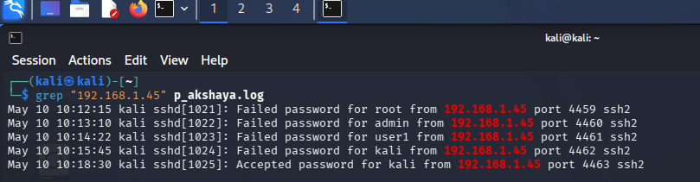

7. command - tail -f /var/log/auth.log
This command shows live login and authentication activities in Linux.
- tail → Displays the last lines of the log file
- -f → Continuously updates new entries in real time
- /var/log/auth.log → Contains login and security-related logs
It is used to monitor successful logins, failed login attempts, and other security events.

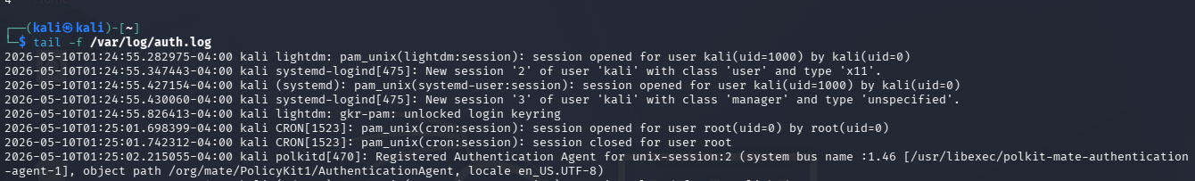

8. last Command
Meaning
The last command displays the history of successful user login and logout activities.
Purpose
It helps administrators check:
- Who logged into the system
- Login time and logout time
- User activity history

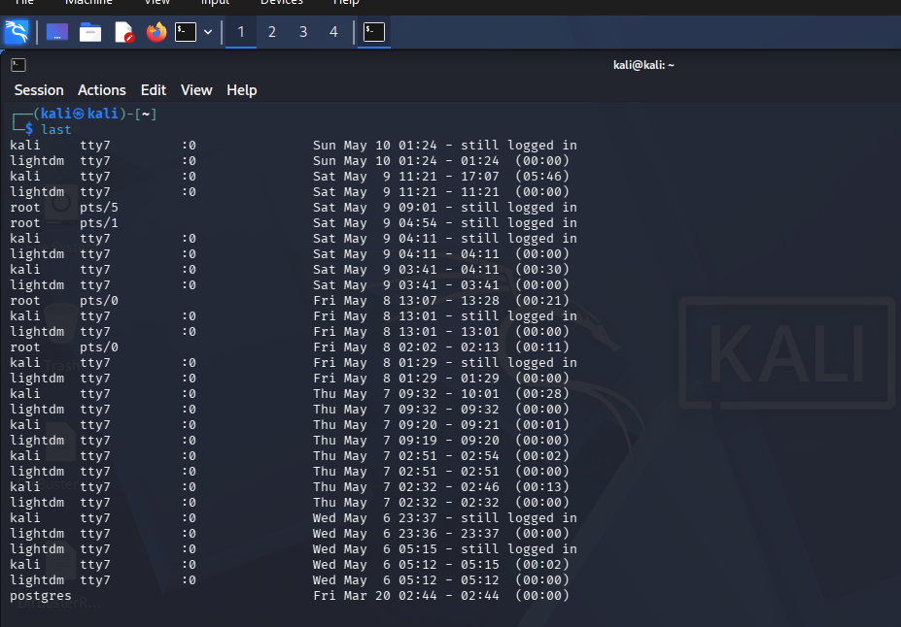

9 . lastb Command
Meaning
The lastb command displays failed login attempts.
Purpose
It helps detect:
- Brute-force attacks
- Unauthorized login attempts
- Suspicious authentication failures
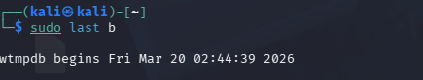
COUNTERMEASURES :
- Use Multi-Factor Authentication (MFA) for extra security.
- Create strong and difficult passwords.
- Disable direct root login through SSH.
- Configure firewall rules to block suspicious access.
- Use intrusion detection tools to monitor attacks.
- Enable SSH key authentication for secure login.

CONCLUSION
This SOC Alert Simulation project shows how security analysts investigate suspicious login activities using Linux logs. During the investigation, multiple failed login attempts and once a successful login were detected from the same IP address, which is called a possible brute-force attack.
The project helped to learn:
- How to analyze system logs
- How to identify cyberattacks
- How to investigate security incidents

----------------------------------------------------------------------------------------------------------------

